**Candidate Module**

*Profile Dashboard:*

What is typically displayed in Dashboard?

Is there a candidate “to-do” or a “your profile is % complete” option we could add here?

*My Profile*:

*Update Candidate Profile*

Separate First Name and Last Name into separate columns. This will help with searching.

Edit to say “Experience in current position”

Adjust Current and expected salary ranges to reflect choices ranging from under 30K to 200K+

Make Country default to Unit States

Have address section first , Then City, Then State, Then zipcode

Remove:

* Age
* Facebook
* Twitter
* Linked-in (unless we can hide this on public profile. We want to keep the identity confidential so a link to a public profile would not be good)

Add

* Mobile Number
* Preferred E-Mail
* Add “Interested in” section with a check all that apply option for

Full Time [ ] Part Time [ ]

Per Diem [ ] Temporary [ ] Travel [ ]

* Desired Position Titles
* Upload Documents ( Resume, References, Cover Letter, Predictive Index Profile)

*Edit Work Experience:*

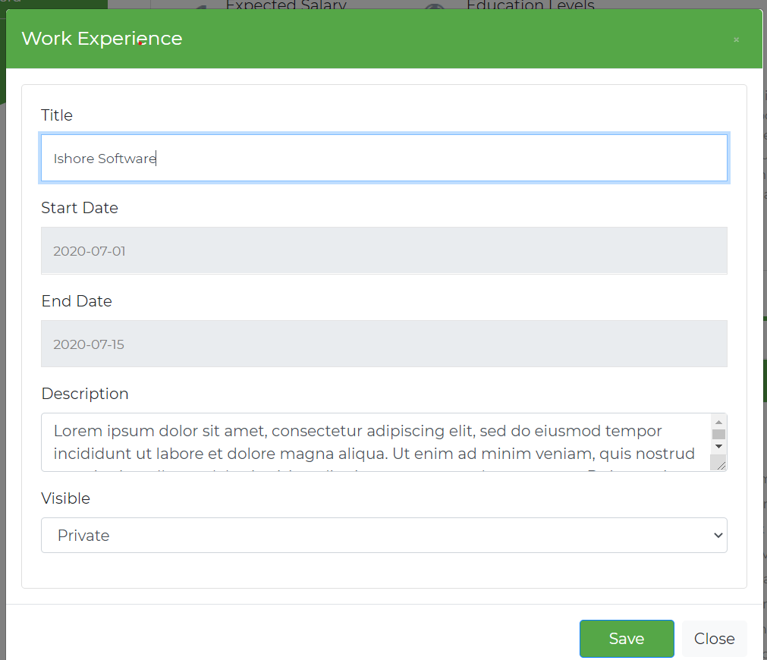

Add

Company

Change start date/end date to “Month/Day/Year” format

*Portfolio*

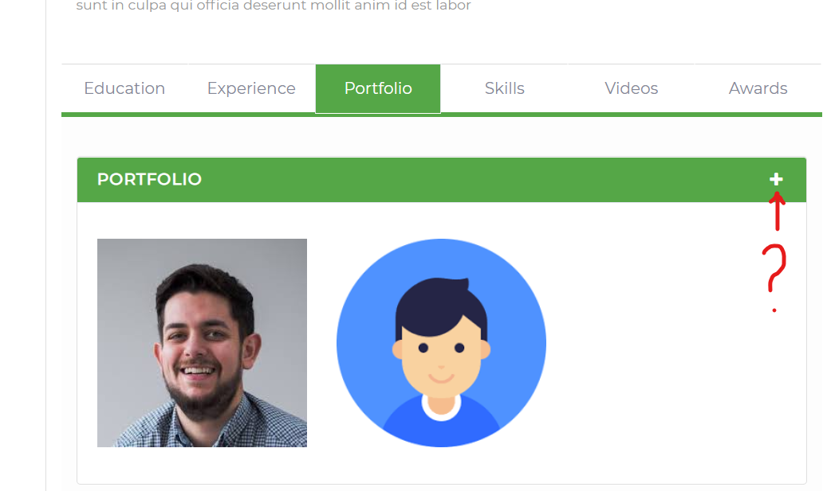

Move this to after Skills and change to “Scouting Report”. Also, the add (+) button is not active?

In this section the candidate can describe themselves and offer insight into their personality and interested.

*Maybe Here we can assign them an Icon based on experience and % of profile completed?:*

Top Prospect Rising Star Pro All Star MVP

    

*Skills*

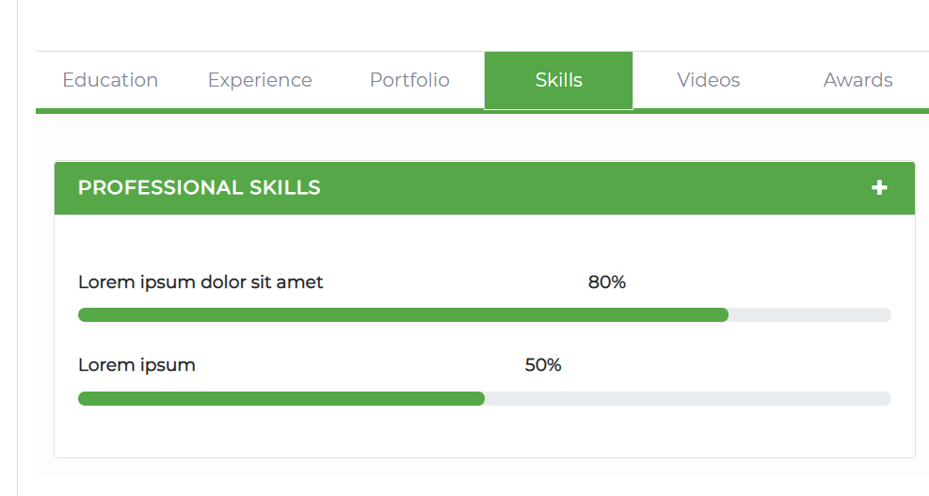

I think this might need to be changed to a different format. There are so many “skills” that someone can have. It might be best to offer them a chance to select some common nursing skills but also add in Skills that can be searchable. Also, many nurses are also “Certified” in various things so maybe change to Skills/Certifications?

An employer may want to filter based on certifications such as:

Certified Wound Care Specialist, Certified Hospice and Palliative Care Nurse, Certified RN Case Manager, Certified MDS Nurse, CPR Certified, etc....

*Video*

Remove this section and replace with scouting report section.

*Awards*

The edit button and add button are not working?

**Public Profile:**

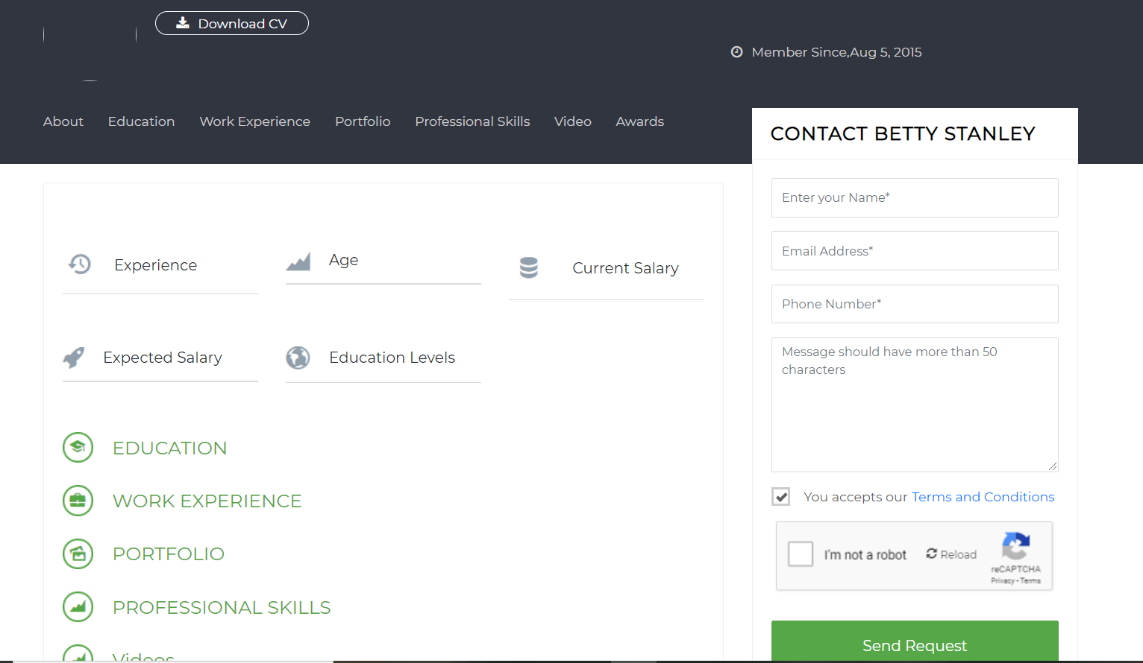

**Contact Candidate Section:**

We would like it to be geared more towards “request to interview” and have a way the client can share the job details for the position they are interested in hiring the candidate for either through a link or a brief written description. “Provide a brief description of the position” added before “message should have no more than 50 character” can we expand it to 150 characters?

Can we add an easy option to add to “short list” (must be a registered user)

Because no candidates will have a profile picture can we have some default Icons that they can choose? Examples:



Nurse Administrator/Mrg Sales/Marketing

Remove:

The option to download resume (they can access the resume after a request to interview is accepted by the candidate)

Remove all social media links (we want to keep the candidates identity confidential)

Age

Add:

Interested in: Full Time, Part Time, Temporary/Contract, Per Diem options in the view somewhere

Add positions interested in somewhere

**Admin Module**

*Company Details:*

*Add:*

*An additional website link that will direct to their job posting page.*

*“Main Contact” to be pinned to the top of the company profile.*

*Company list*

*Add:*

*Again, have the jobs website added*

*State and Zipcode*

*Search options: Should be able to search for distance from Zipcode*

*Candidates list:*

Add

City State and Zipcode

Search for distance from zipcode

“advanced search” options such as licensure, title, keywords etc...